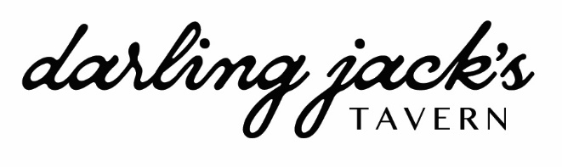

RESTAURANT WEEK DINNER
$45 per person

SPECIALTY COCKTAIL $14

MIA
knob creek, montenegro amaro, aperol, lemon

FROM THE CHEF

WHIPPED FETA (V)
za’atar, olive oil, sherry roasted beets, sumac, toasted MB sourdough

FIRST COURSE

CLAM CHOWDER
cup of new england style clam chowder, bacon, scallions

CHICORY + NAPA SALAD (V)
honeycrisp apple, fennel, marcona almonds,
medjool date-aged sherry dressing, shaved manchego

GRILLED CARROTS (V)
lemon honey glazed carrots, whipped labneh, za’atar, pepitas,
herbs, pickled raisins

STEAK TARTARE
Pasture raised beef, salty potato chips, garlic aioli,
royer mountain cheddar, fresh horseradish

SECOND COURSE

SHRIMP SPAGHETTI
garlic, blistered tomatoes, calabrian chile, capers, crab butter

RICETTE + ALMOND PESTO
swiss chard, butternut squash, seared mushrooms, whipped feta, basil

jACK’S Burger
la frieda double smash patty, tavern sauce,
american cheese, griddled onions, merzbacher sweet potato bun
green meadow farm half sour kirby pickles, fries

fish & chips
beer battered cod, pickle brine tartar, gingered cabbage slaw, tavern sauce for fries

braised short rib “pot roast”
parsnip farotto, roasted winter vegetables, short rib jus, olive salsa verde, fresh horseradish, herbs

THIRD COURSE

DARK CHOCOLATE MOUSSE
whipped labneh, toasted hazelnuts, mini malt-balls

BANANA PUDDING
vanilla wafers, whipped mascarpone, crunchy peanuts

WARM APPLE BOURBON BREAD PUDDING
bourbon caramel, salty walnuts, crème fraiche ice cream

